NBA POWER BI ANALYSIS
INTRODUCTION:-
The NBA (National Basketball Association) is the premier professional basketball league in North America. Founded in 1946, it's a global sports and entertainment phenomenon, featuring the world's most talented basketball players who compete in a regular season followed by playoffs culminating in the NBA Finals. The league is known for its fast-paced, high-scoring style of play and its iconic franchises and players. This NBA player analysis dashboard provides key insights into player performance and demographics. It visualizes data on points, assists, rebounds, 3-point percentage, and age, enabling users to compare players and identify trends across different positions. This analysis helps understand player contributions and potentially inform strategic decisions.

PLAYER ANALYSIS:-
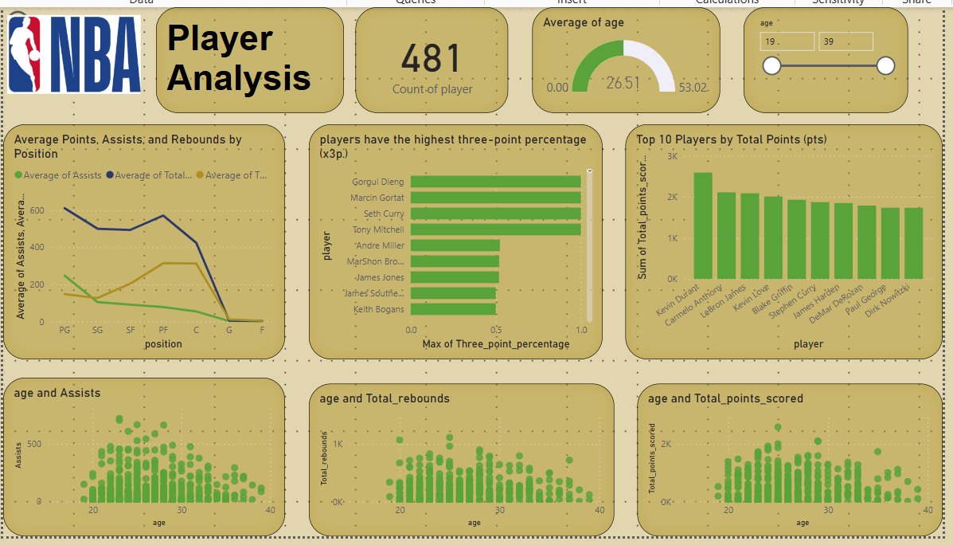

Graphs and their Description :-
Card (19.39): Displays the average age of NBA players.
Card (481): Shows the total count of NBA players in the dataset.
Card (0.00, 26.51, 53.02): Illustrates the distribution or range of some metric (likely related to age), possibly showing minimum, average, and maximum values.
Line Chart (Average Points, Assists, and Rebounds by Position): Depicts the trend of average points, assists, and rebounds across different player positions.
Bar Chart (Players with Highest Three-Point Percentage): Ranks players based on their three-point shooting accuracy.
Column Chart (Top 10 Players by Total Points): Compares the top 10 players according to their total points scored.
Scatter Chart (age and Assists): Explores the correlation between player age and the number of assists they provide.
Scatter Chart (age and Total_rebounds): Analyzes the relationship between player age and their total rebounds.
Scatter Chart (age and Total points_scored): Examines the correlation between player age and their total points scored.

Team Analysis :-
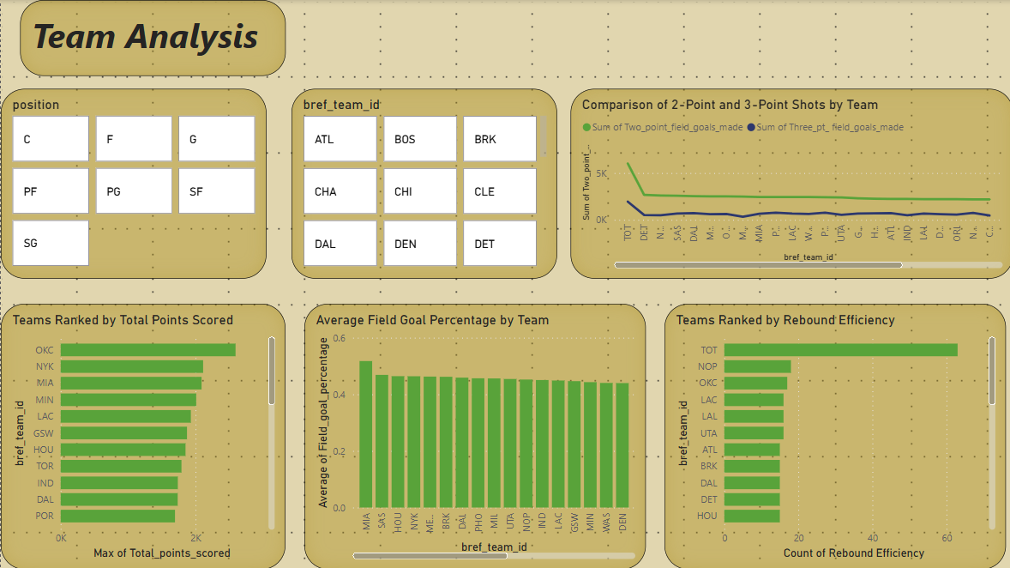
Graphs and their Description :-
Slicer (Position): Filters data by player position (C, F, G, PF, PG, SF, SG).
Slicer (bref_team_id): Filters data by team abbreviation (e.g., ATL, BOS, BRK).
Multi-Row Card (Position Grid): Displays selected player positions in a grid format.
Multi-Row Card (bref_team_id Grid): Shows selected team abbreviations in a grid format.
Line Chart (Comparison of 2-Point and 3-Point Shots by Team): Compares the number of two-point and three-point shots made by different teams
Bar Chart (Teams Ranked by Total Points Scored): Ranks teams based on their total points scored..
Column Chart (Average Field Goal Percentage by Team): Shows the average field goal percentage for each team..
Bar Chart (Teams Ranked by Rebound Efficiency): Ranks teams according to their rebound efficiency.

Seasonal Trends & Shooting & Efficiency
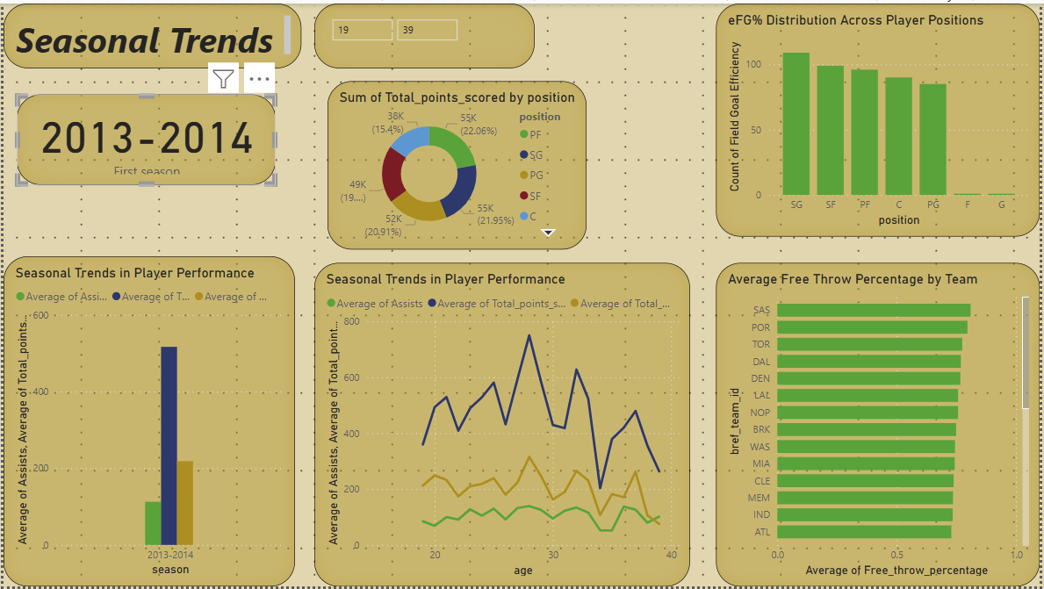
Slicer (Season): Filters data by NBA season (e.g., 2013-2014).
Slicer (First Season): Filters data based on whether it's a player's first season.
Multi-Row Card (19, 39): Displays two numerical values, potentially related to age or years in the league.
Column Chart (eFG% Distribution Across Player Positions): Shows the distribution of effective field goal percentage across different player positions.
Donut Chart (Sum of Total points_scored by position): Illustrates the proportion of total points scored by each player position.
Line Chart (Seasonal Trends in Player Performance - Assists): Displays the trend of average assists over a period (likely related to age or career).
Line Chart (Seasonal Trends in Player Performance - Points): Shows the trend of average total points over a period (likely related to age or career).
Bar Chart (Average Free Throw Percentage by Team): Compares the average free throw percentage for different teams.
Card (Count of Field Goal Efficiency): Displays a count or measure of field goal efficiency.
Card (Average of Free_throw_percentage): Shows the average free throw percentage, likely across all players or a selected group.
Bar Chart (Average of Assists, Average of Total points): Compares average assists and average total points for different teams.

